|  |  |  |  |  |  |  |
| --- | --- | --- | --- | --- | --- | --- |
| VILNIAUS KOLEGIJA  UNIVERSITY OF APPLIED SCIENCES  FACULTY OF ELECTRONICS AND INFORMATICS  Image result for viko logo | | |  | | | VILNIUS COLLEGE  Image result for viko logoFACULTY OF ELECTRONICS AND INFORMATICS |
|  | | |  | | |  |
| **BUSINESS MANAGEMENT SYSTEMS** | | |  | | | **INTRODUCTION TO INFORMATICS** |
| PRACTICAL ASSIGNMENT  PRACTICE WORK NO.1  6531BX028 PI18E | | |  | | | PRACTICAL ASSIGNMENT  SPOTIFY USER MANUAL  6531BX028 PI18E |
| STUDENT | DŽIUGAS PEČIULEVIČIUS | STUDENT | | DŽIUGAS PEČIULEVIČIUS |
| (SIGNATURE)  3/20/2020 | | |  | | | LECTURER |
| LECTURER | TATJANA LIOGIENĖ | (SIGNATURE)  10/17/2018 | | VIRGILIJUS KUKLIERIUS |
| (SIGNATURE)  3/20/2020 | | |  | | | 2018 |

2020

**TABLE OF CONTENTS**

INTRODUCTION 4

ORGANIZATION’S ACTIVITIES 5

MODULES SELECTION 7

FUNCTIONALITY DEMONSTRATION 9

WEBSITE DEMONSTRATION 21

ECOMMERCE DEMONSTRATION 22

CONCLUSIONS 23

**TABLE OF FIGURES**

Figure 1- 0 level DFD diagram 5

Figure 2 - Inventory Management module 7

Figure 3 - Invoicing Management module 7

Figure 4 - Manufacturing module 7

Figure 5 - Sales management 7

Figure 6 - Website builder module 8

Figure 7 - e-commerce module 8

Figure 8 - Email marketing module 8

Figure 9- Inventory Management module 9

Figure 10 - All existing products 9

Figure 11 - Product categories 10

Figure 12 - Invoicing Management module 10

Figure 13 - Order description 10

Figure 14 - Invoice creation pt.1 11

Figure 15 - Invoice creation pt. 2 12

Figure 16 - Invoice validation 13

Figure 17 - Sending the Invoice pt1 14

Figure 18 - Sending the Invoice pt2 14

Figure 19 - Invoice example 15

Figure 20 - Manufacturing module 16

Figure 21 - Choose a product we want to manufacture 16

Figure 22 - Select the quantity how many items are needed. 17

Figure 23 - Confirm production 17

Figure 24 - Mark as Done after finishing the order 18

Figure 25 - We can see all our previously made orders 18

Figure 26 - Sales management 19

Figure 27 - Sales dashboard 19

Figure 28 - Email marketing module 20

Figure 29 - Newsletter signup 20

Figure 30 - Website representation pt1 21

Figure 31 - Website representation pt2 21

Figure 32 - Product page demonstration 22

# INTRODUCTION

**Program used for charts**

Website: odoo.com

**Goal**

Our goal is to get familiar with odoo software and do practical tasks for Business Management subject.

**Requirements**

* Title sheet;
* Content;
* Introduction (purpose of the work and tasks to achieve it (steps of pw1));
* Description of the organization's activities (Presentation of the organization with its activities (services, products); Zero-level DFD with description);
* Suggested ODOO modules (name of module and justification why it is offered to this organization);
* Detailed description of modules (demonstrating modules with sample data, pictures, description);
* Conclusions.

# ORGANIZATION’S ACTIVITIES

This work is about a small watch company which is really passionate about their work whose goals are to make watches affordable to everyone. This company would sell watches, watch straps and replacement items, and other accessories like eyewear and jewelry. Company would also offer replacements for defected items that have been bought online. Just like in last semester we talked how the company process is managed.

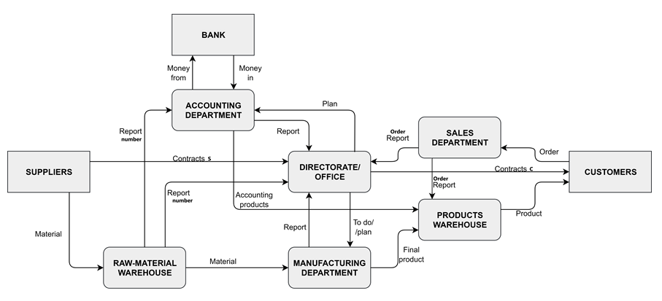

Figure 1- 0 level DFD diagram

|  |  |
| --- | --- |
| **Process name** | **Process description** |
| ACCOUNTING | Managing company’s money. Takes it into and out of the bank. Accounting department provides office a report on how company is doing money-wise and other similar statistics.  Accounting department also takes a plan from office on what to do and report from raw-material warehouse on number of things it is stored. |
| DIRECTORATE / OFFICE | This basically is a core of a company. All managers and shareholders are here.  Office provides contracts to customers when they buy something. They also provide a plans on what to do to manufacturing and accounting departments. Office also provides suppliers with a plan on ordered things and what is needed to be sent to raw-material warehouse They take in reports form all the departments of a company. |
| RAW-MATERIAL WAREHOUSE | Warehouse where all material necessary is stored. Material is gathered from a supplier.  When needed – necessary material is transported to manufacturing department and a report is then sent to an accounting department and an office. |
| MANUFACTURING DEPARTMENT | In this department all items are assembled and when “ready to be sold”, then they are transported to product warehouse. Then a report is sent to an office. Manufacturing department takes material from raw-material warehouse and reports office about it. |
| PRODUCT WAREHOUSE | Product warehouse is where all final products ready to be sold are stored. It can be parts of computers or it can also be assembled computers from manufacturing department. Product warehouse is managed by accounting department. All products from warehouse are sent to a customer. |
| SALES DEPARTMENT | Sales department gets a number of things customers have ordered and that number of sales report goes to the office. |

# MODULES SELECTION

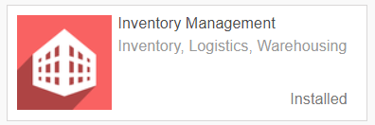

Figure 2 - Inventory Management module

Inventory management module helps our shop to keep track of our inventory and create products and their categories.

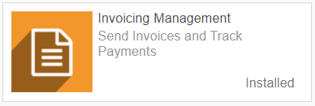

Figure 3 - Invoicing Management module

Helps us organize invoices.

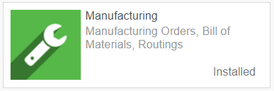

Figure 4 - Manufacturing module

Manufacturing module helps our business to keep track of orders and the quantity of items that need to be produced.

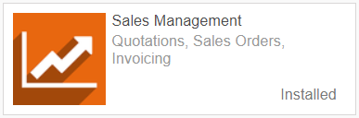

Figure 5 - Sales management

Helps us to keep track of orders that have been made and send abandoned cart emails.

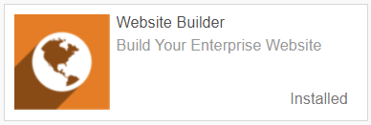

Figure 6 - Website builder module

Helps us quickly build websites with drag and drop options.

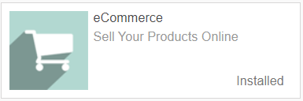

Figure 7 - e-commerce module

Helps us create product pages.

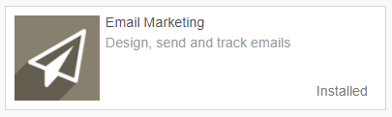

Figure 8 - Email marketing module

Email marketing solution. Helps us grow the base of existing customers with marketing emails.

# FUNCTIONALITY DEMONSTRATION

**Inventory management**



Figure 9- Inventory Management module

As mentioned above Inventory management module helps our shop to keep track of our inventory and create products and their categories.

One of the features of this module is that we can keep track of our products, edit them and create new ones.

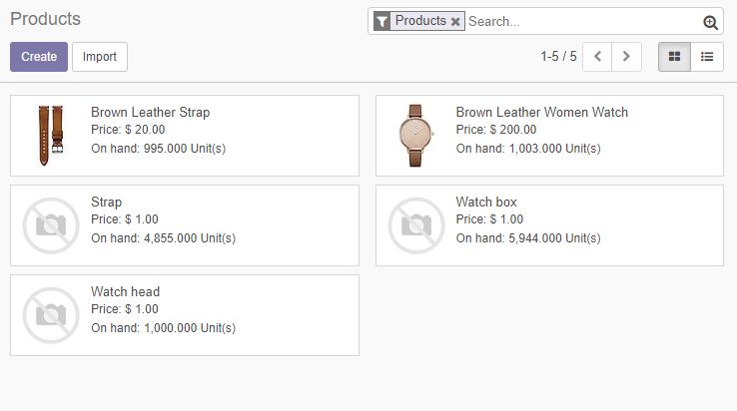

Figure 10 - All existing products

Another feature of this module is that it lets us to create categories and subcategories for our products, which makes user interference and search for specific products a lot simpler.

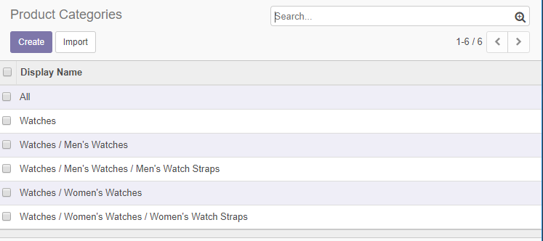

Figure 11 - Product categories

**Invoicing Management**



Figure 12 - Invoicing Management module

Invoicing management module helps us create professional looking invoices and send them to our customers.

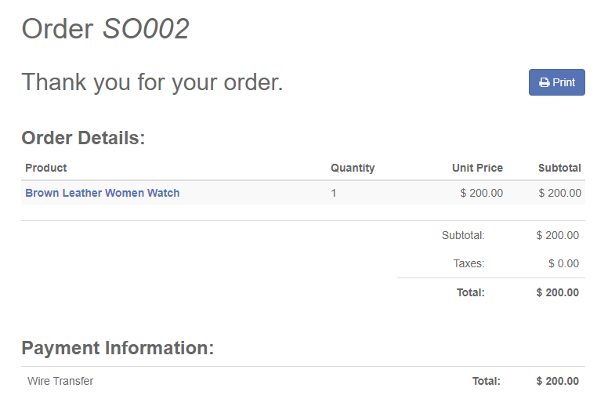

Figure 13 - Order description

When someone makes an order we will want to check the order first.

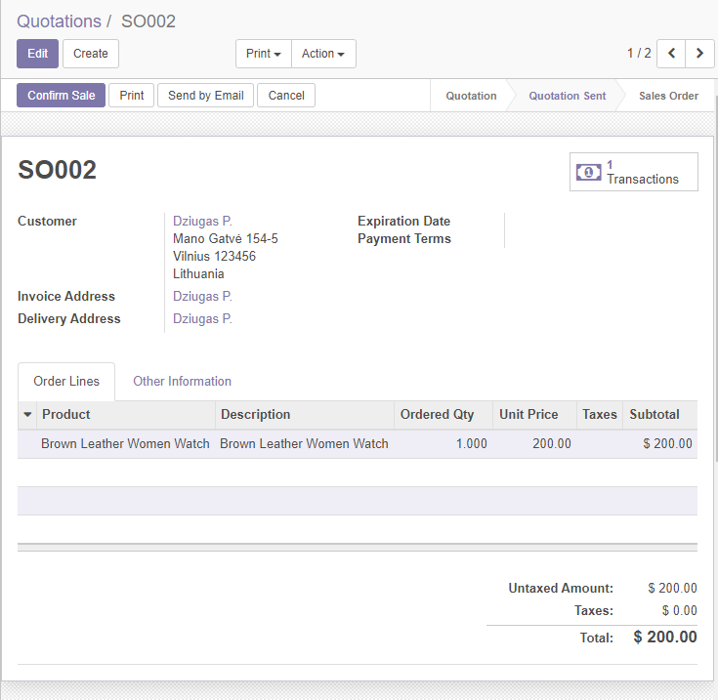

Figure 14 - Invoice creation pt.1

After confirming the order, we can now create an invoice.

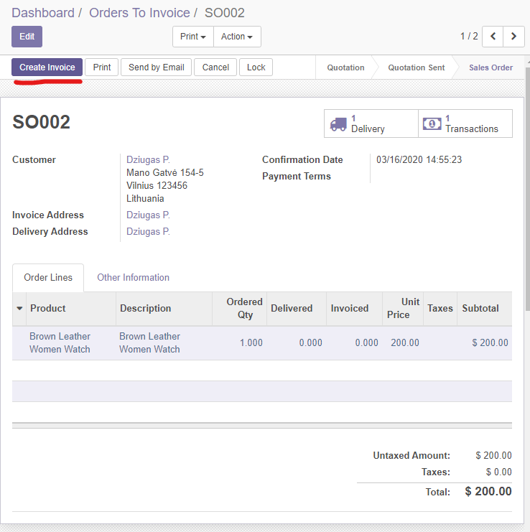

Figure 15 - Invoice creation pt. 2

When we created the invoice we want to validate it.

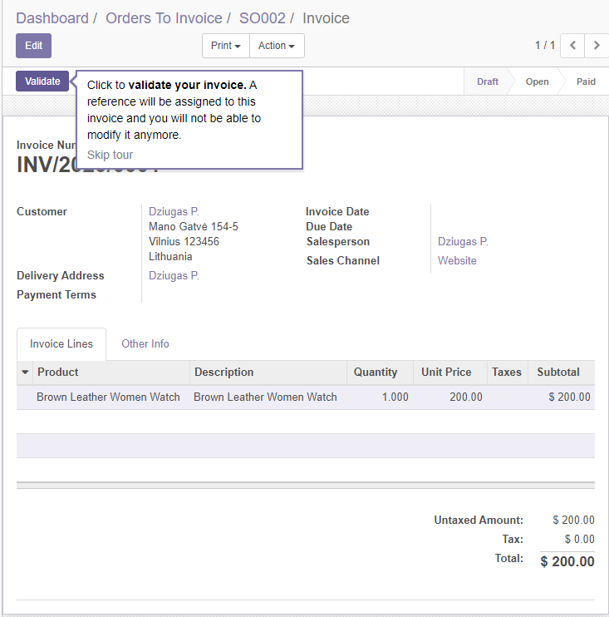

Figure 16 - Invoice validation

After validating the invoice, we will now be able to send the invoice to the customer.

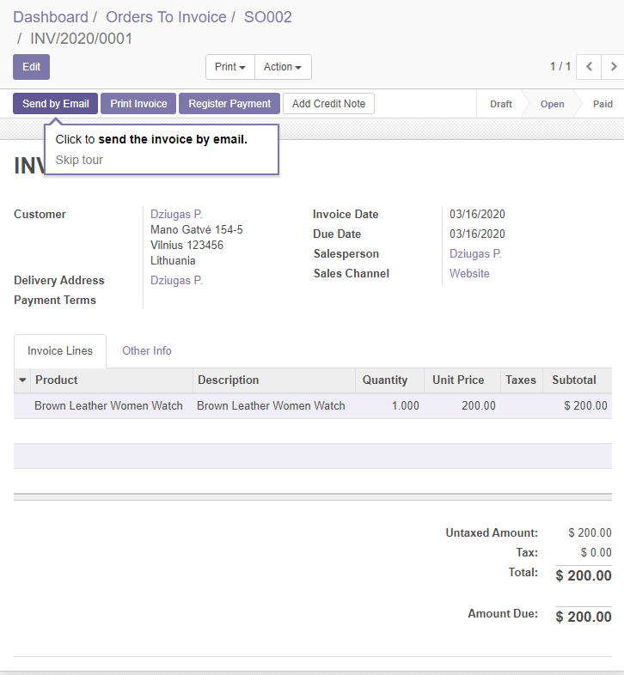

Figure 17 - Sending the Invoice pt1

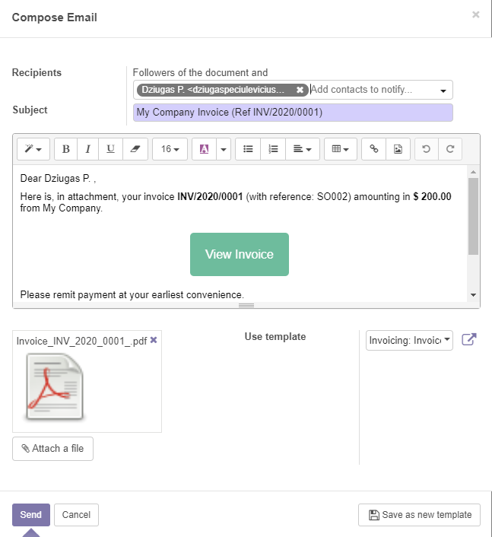

Figure 18 - Sending the Invoice pt2

After clicking the send button the customer should receive the invoice looking something similar to something like this below:

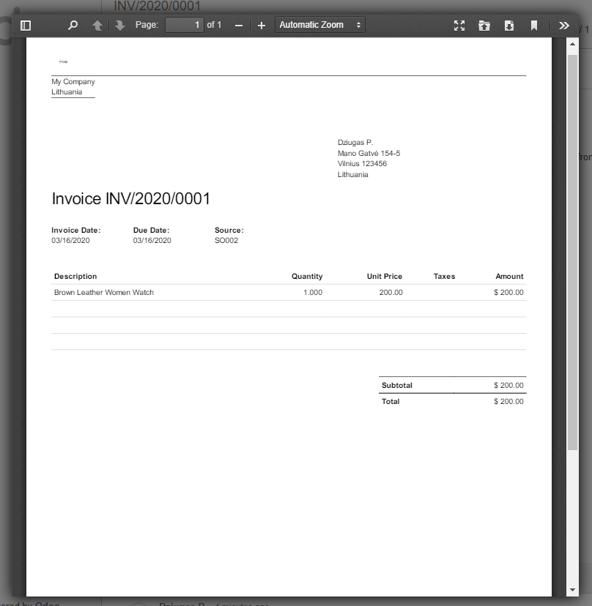

Figure 19 - Invoice example

**Manufacturing**



Figure 20 - Manufacturing module

Manufacturing module helps our business to keep track of orders and the quantity of items that need to be produced.

In the example we see a way how we can make manufacturing orders to make new products for our inventory.

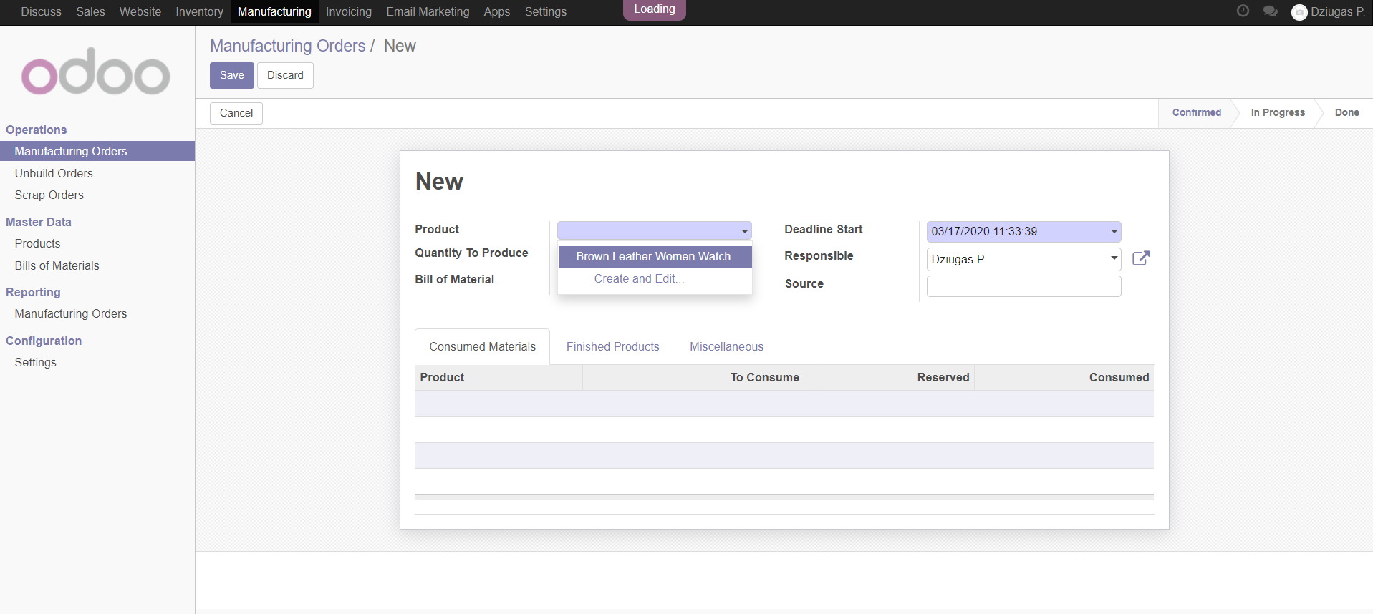

Figure 21 - Choose a product we want to manufacture

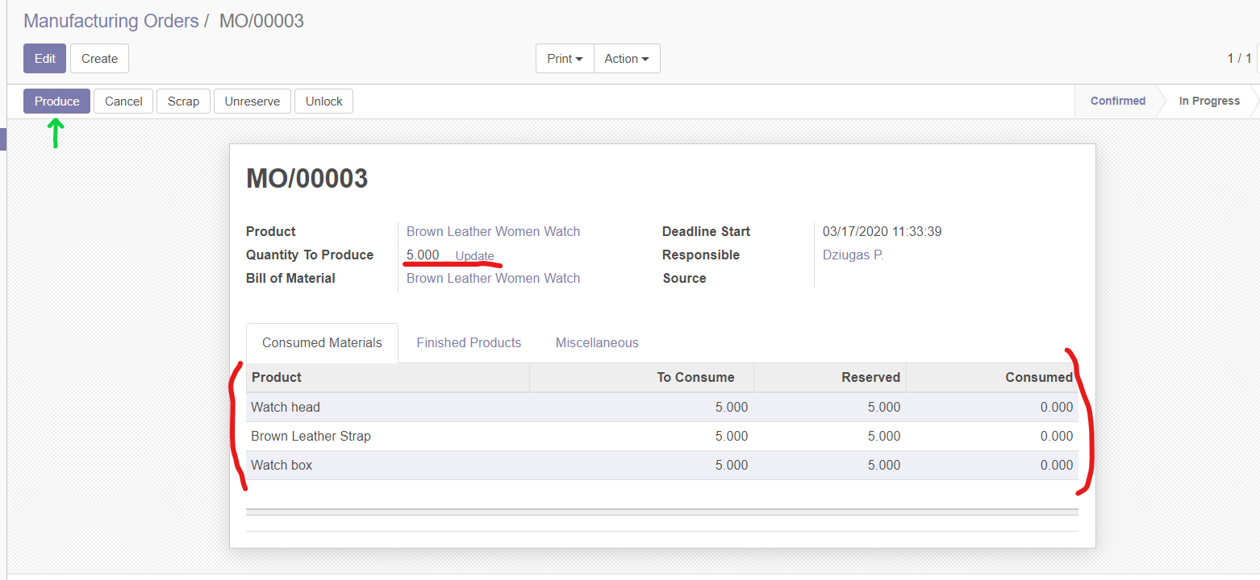

Figure 22 - Select the quantity how many items are needed.

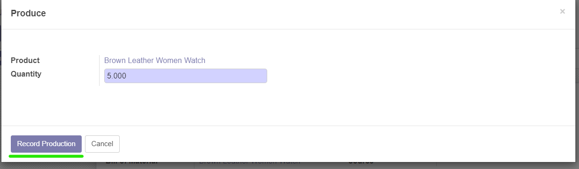

Figure 23 - Confirm production

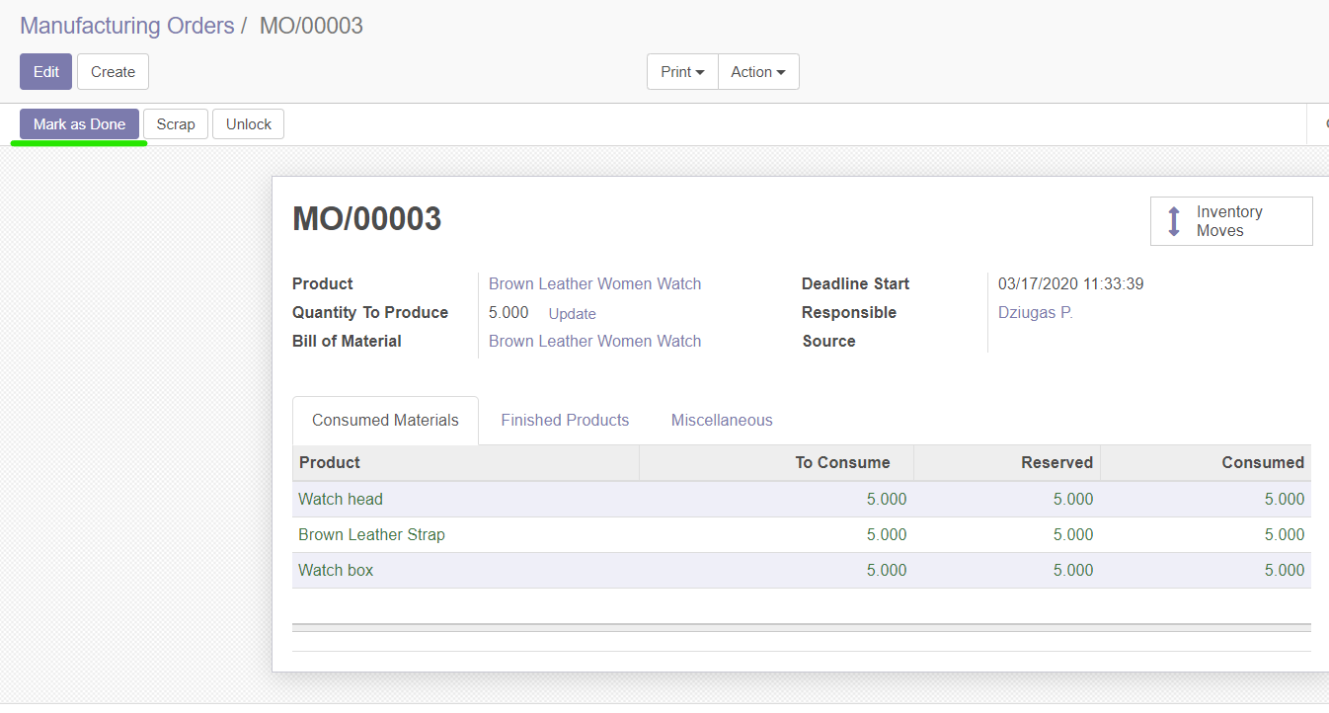

Figure 24 - Mark as Done after finishing the order

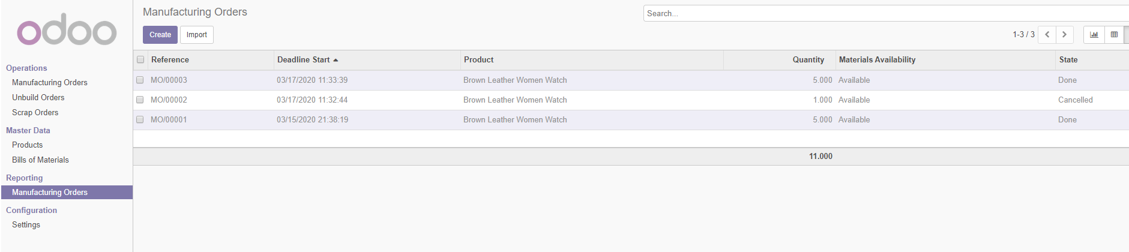

Figure 25 - We can see all our previously made orders

**Sales Management**



Figure 26 - Sales management

Sales management module helps us to keep track of orders that have been made and send abandoned cart emails. We can see abandoned carts and send recovery emails to our users which brings the conversion rate up. Sales management module basically helps us manage orders, send invoices, and recover abandoned carts.

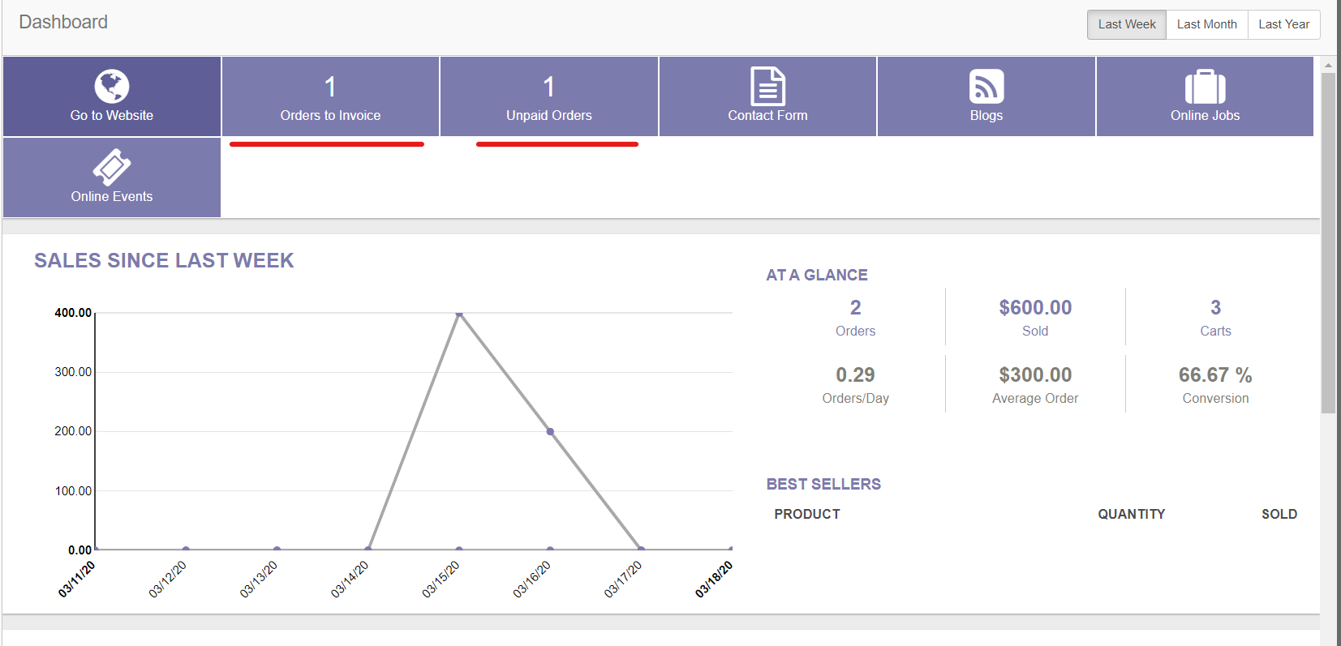

Figure 27 - Sales dashboard

**Email Marketing**



Figure 28 - Email marketing module

Email marketing solution. Helps us grow the base of existing customers with marketing emails.

Basically we can offer people some benefits for subscribing to our newsletter. Once they subscribe we will have another way of reaching our customers and send subscribers our marketing emails for free!

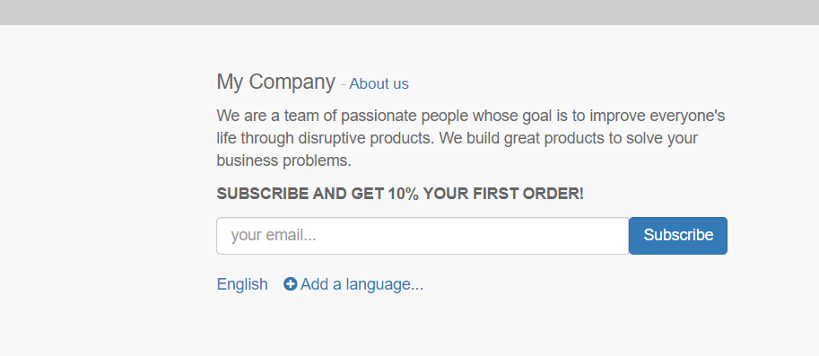

Figure 29 - Newsletter signup

# WEBSITE DEMONSTRATION

# This is a short website demonstration. Could not manage to make the thumbnail cover the entire page and is not really made for big screens or mobile responsive, but this representational page welcomes a user. Offers the user to check out new items. A watch below new arrivals section is offered to a customer as a “best watch” to gift a loved one and a button leads to the product page.

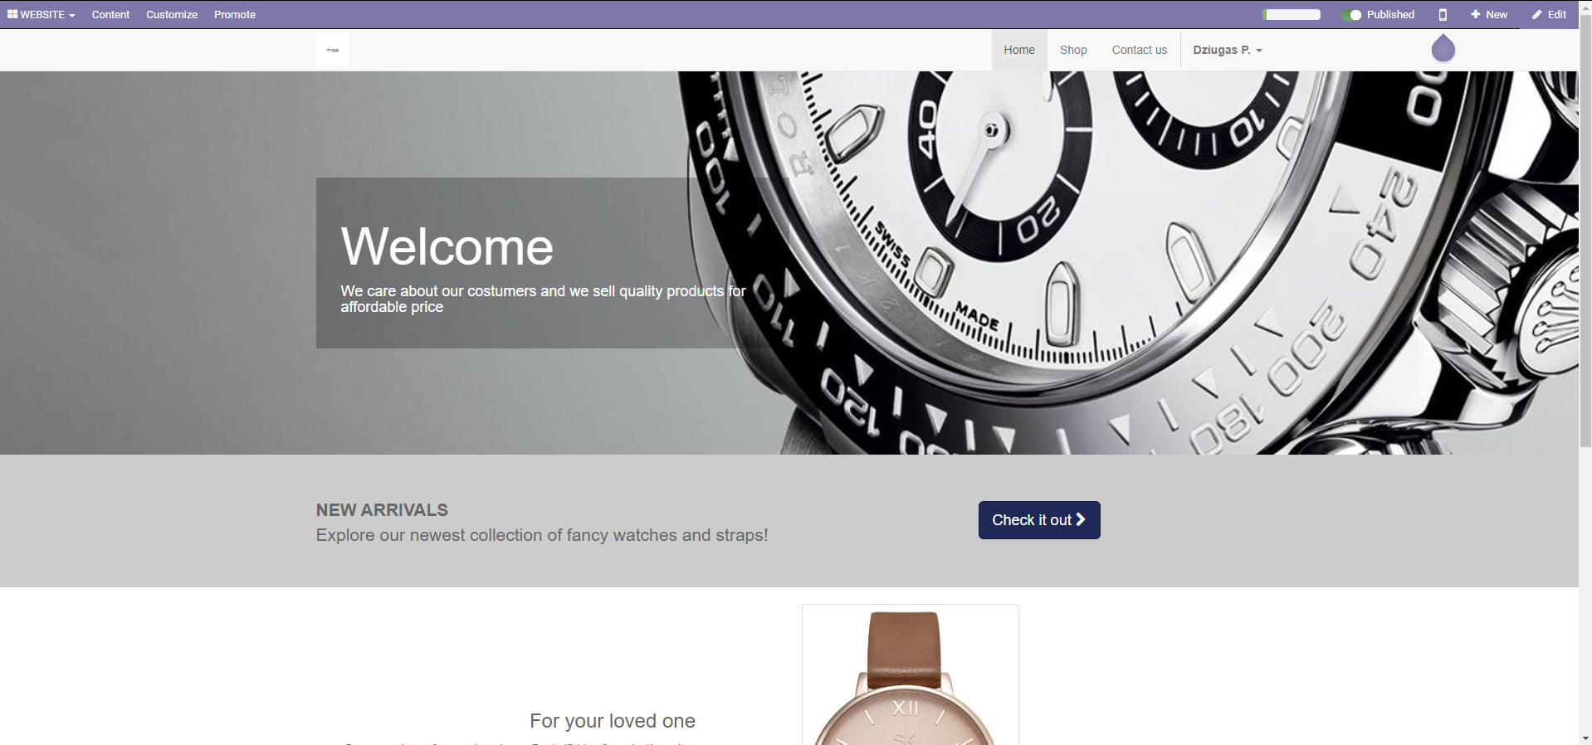

Figure 30 - Website representation pt1

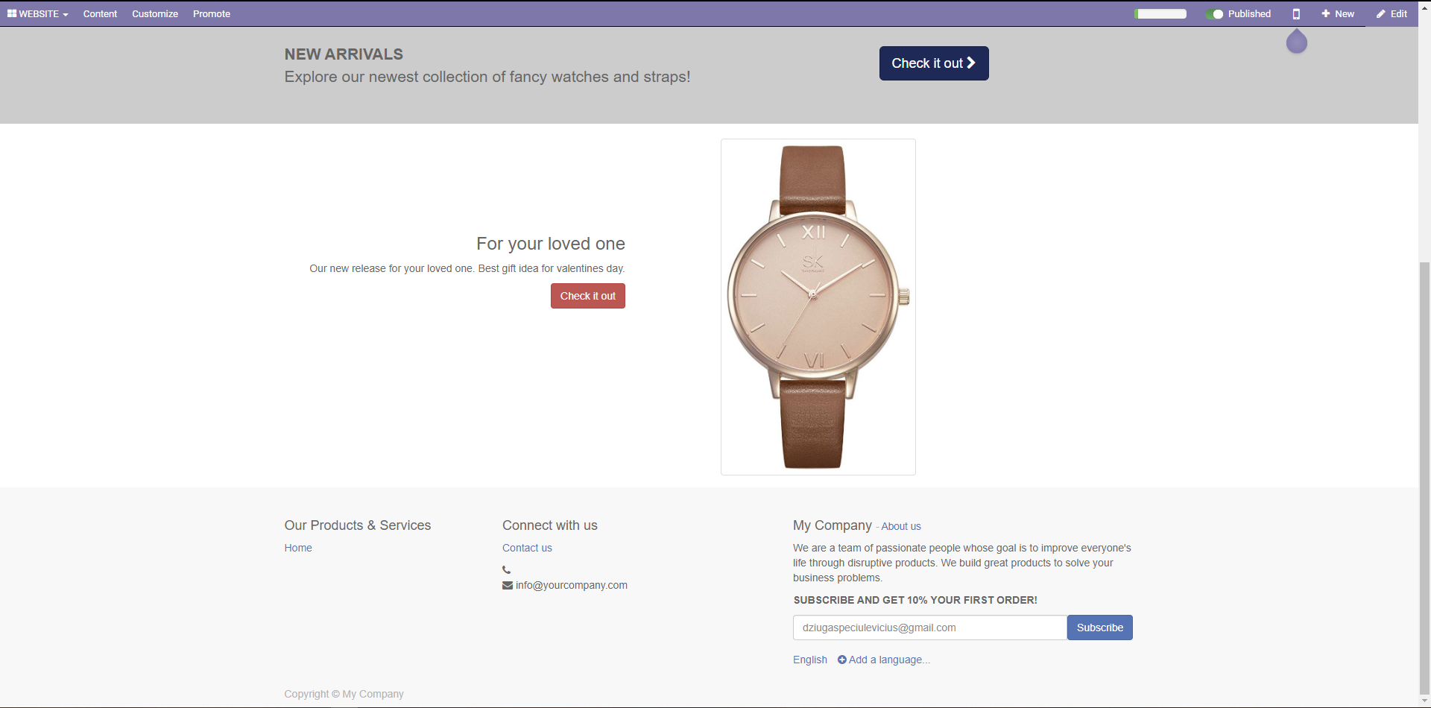

Figure 31 - Website representation pt2

# ECOMMERCE DEMONSTRATION

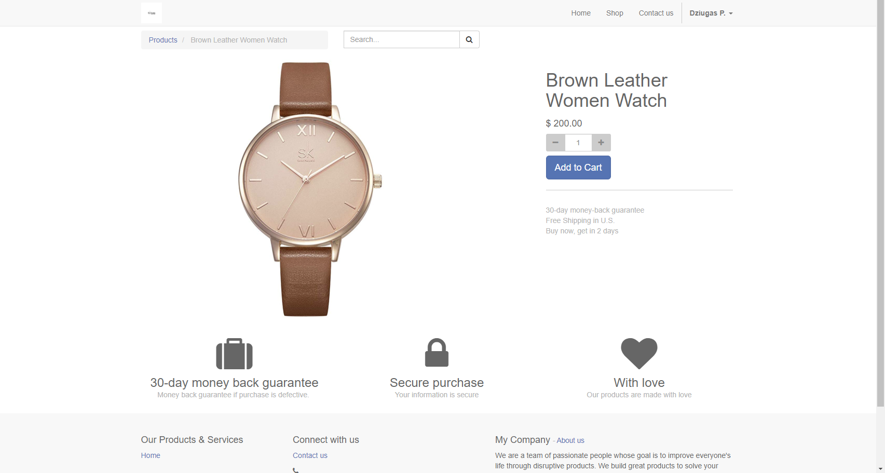

Figure 32 - Product page demonstration

# The product page does not have a lot of functionality, as well and the shop page:

# 

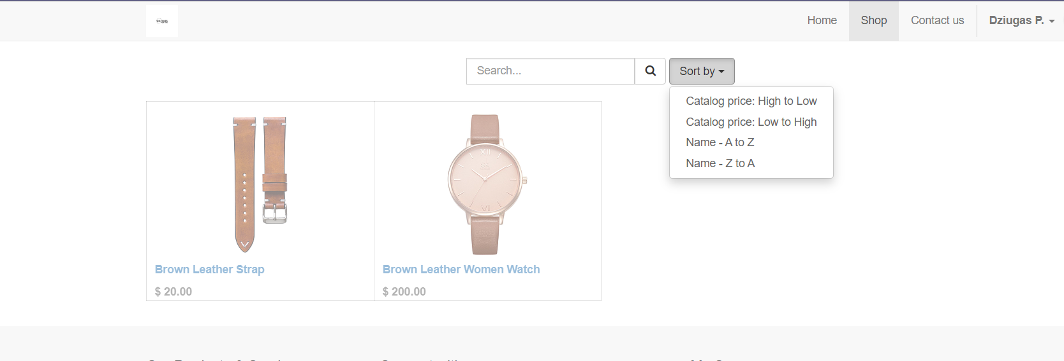

# User is able to search for the item by its keywords and see the items. User can also sort products by name or price.

# CONCLUSIONS

# ODOO (ERP) systems helps people to manage many business processes (tasks) like purchases, accounting, manufacturing, sales, which are integrated into one system, and everything is just within few clicks. It also helps company save money since everything in the system is computerized. Implementing computerized business is pretty easy and provides real time access to data.